Name: Period: Due Date:
7th Grade Social Studies Unit 1 Packet- Age of Exploration

Part 1: Vocabulary (40% of grade): identify or explain the significance of each term/ person/ place listed using the internet, suggested sites, dictionary.com, history.com, biography.com
1.2 Causes of Exploration | --------------------------------------------------------------------------------------------------
Prince Henry the Navigator
Silk Road
Small Pox
Vasco de Gama
Ferdinand Magellan
Bartolomeu Dias
Astrolabe
Caravels
Marco Polo
Gil Eanes
Straight of Magellan
Cape Verde Islands
1.3 Colubus/ Columbian Exchange | ----------------------------------------------------------------------------------------------------------------------------------------------------------------------------------------------------
Christopher Columbus
Columbian Exchange
Colony
King Ferdinand of Spain
Queen Isabella of Spain
1.4 Explorers
Giovanni da Verazzano
Hernan Cortes
Francisco Pizarro
Conquistador
Part 2: Essential Questions (40 % of grade, 20% each question): Answer two (2) of the three (3) questions thoroughly. You may answer all for possible extra credit (maximum 10 points- be sure to label which answer is for extra credit.
1. Explain the significance of the phrase “God, Glory, and Gold” to the exploration and settlement of the Americas by the Spanish, Portuguese, English, and French in the southeast area of North America?

2. Identify three new technological advances during the Age of Exploration and evaluate the impact it had on the New World and Africa.

3. Identify three explorers and describe their expeditions from the Age of Exploration. Assess the importance of each expedition and the impact it had on future expeditions.

Part 3: Document Analysis (20% of grade, 5% each task): Using the attached HIPP Document Analysis sheet interpret the meaning of the cartoon.
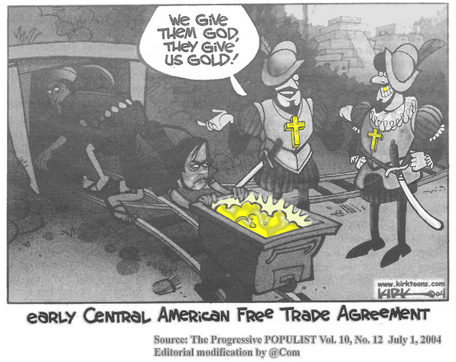

H.I.P.P.: DBQ and Document Analysis

1. HISTORICAL CONTEXT-Connect the document to specific historical events using outside examples. Connect the document across time to earlier and/or later eras or across space to events happening in different places. (What else is going on in the world that you need to know to help you understand the document? This is the background info, like the scrolling text at the beginning of Star Wars)

2. INTENDED AUDIENCE-Identify a person or group the author expects to inform or influence.

3. POINT OF VIEW-What do think the author’s point of view is on the topic shown in the document? Is there any evidence of bias? If so provide specific details.

4. PURPOSE-Why did the author create the source?

