Name: Period: Due Date:
7th Grade Social Studies
Unit 6 –WWI and Russian Revolution
Part 1: Vocabulary: (40% of grade) identify or explain the significance of each term/ person/ place listed using the internet, use dictionary.com or history.com
Causes of WWI | ----------------------------------------------------------------------------------------------------------------------------------------
- Militarism
- Neutrality
- Archduke Franz Ferdinand
- Gavrilo Princip
- Triple Alliance
- Triple Entente
- Alliance
- Propaganda
- Dictator
Fighting WWI and Changes in Weaponry | --------------------------------------------------------------------------------------------------------------------------------------------------------------------------------------------------------------------------------------------------------------------------------
- “No man’s land”
- U-Boat
- Zeppelin
- Mustard Gas
- Trench Warfare
- Zimmerman Note
Russian Revolution | ----------------------------------------------------------------------------------------------------------------------------------------
- Vladimir Lenin
- Bolshevik
- Czar Nicholas II
Treaty of Versailles | ---------------------------------------------------------------------------------------------------------------------------------------
- Armistice
- Woodrow Wilson
- Treaty of Versailles (1919)
- League of Nations
- Woodrow Wilson’s Fourteen Points
Part 2: Essential Questions: (40% of grade; 20 points each, all 3 possible 10 points Extra Credit) On a separate sheet of paper, answer each question thouroughly

  - What impact did technology have on World War I? Be sure to include specific names of the technologies and their effect on the war.

  - What were the long term and short term causes of WWI? Be sure to explain what each cause was- do not just list them.

  - What were the terms of the Treaty of Versailles? In your opinion were they fair, explain why you like them or what you would change?

Part 3: Document Analysis: Using the attached HIPP Document Analysis sheet interpet the meaning of the cartoon below.
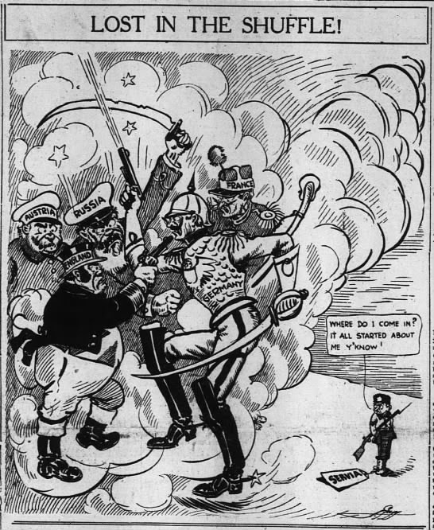
H.I.P.P.: DBQ and Document Analysis (20% of grade- 5 points each)
1. HISTORICAL CONTEXT-Connect the document to specific historical events using outside examples. Connect the document across time to earlier and/or later eras or across space to events happening in different places. (What else is going on in the world that you need to know to help you understand the document? This is the background info, like the scrolling text at the beginning of Star Wars)

2. INTENDED AUDIENCE-Identify a person or group the author expects to inform or influence.

3. POINT OF VIEW-What do think the author’s point of view is on the topic shown in the document? Is there any evidence of bias? If so provide specific details.
4. PURPOSE-Why did the author create the source?

